COMP1003: Algorithms, Data Structures and Mathematics
A&D Practical EBNFs

1) Consider the following “language” expressed in extended Backus Naur Form:

S ::= NP VP '.' ;
NP ::= ( DET (ADJ)* NOUN ) | NAME ;
DET ::= 'A' | 'The' ;
ADJ ::= 'red' | 'smelly' | 'hungry' ;
NOUN ::= 'dog' | 'cat' ;
NAME ::= 'Gonzo' | 'Hugo' | 'Tomcat';
VP ::= 'walks by' | 'meows' | 'speaks' | 'barks' ;

Decide whether the following sentences are syntactically correct or not:

Sentence S | What goes wrong (if any)
Hugo is hungry . | no 'is' in grammar
A Tomcat speaks | No dot at end and "Tomcat" not a NOUN after "A"
A Hugo speaks . | DET 'A' too much
Gonzo meaows . | Typo; 'meows' would make sentence correct
The red hungry dog barks .
A red smelly smelly smelly cat walks by .

Consider the following syntax definitions of subsets of arithmetic expressions in extended Backus Naur Form, where '+' and '-' refer to the usual addition and subtraction operations, '*' and '/' refer to multiplication and division, and 'x', 'y', 'z' are arithmetic variables. You should know arithmetic expressions from school, e.g., a+b*c, and the like, or from any programming language you know.

2a)
expression ::= term ('+' | '-' ) term ;
term ::= variable ( '*' | '/' ) variable ;
variable ::= 'x' | 'y' | 'z' ;
Which of the following expressions are well-formed and which not? Give reasons.

1 need two terms; and 1 is not a terminal symbol
x need two terms
-x + x no negation
x+1 no 1
x+y "+" needs terms to the left and right but terms must be products or quotients
x + y as previous
x+y+z need exactly 2 terms
x*x – y*x ok
1/x + y*x no 1
1/x/y + x*x need two factors in first term and no 1
x/y/z need exactly two factors
x + y + z need exactly two terms
x + y + z * x need exactly two terms

2b)
expression ::= term ( ('+' | '-' ) term ) ;
term ::= integer ( ( '*' | '/' ) integer );
integer ::= '1' | '2' | '3' ;

Which of the following expressions are well-formed and which not? Give reasons.

1 need two terms
x no x and need two terms
x+1 no x
x+y no x and y
1 + 2*3 need two integers in first term
1 + 2 + 3 need two terms only
1*3 – 2*3 ok
1/x + y*x no x,y
1/x/y + x*x no x, y, and need two integers in first term
1*2*3 need two integers
x/y/z need integers 1,2,3 only
x + y + z no x, y, z
x + y + z * x no x, y, z,

2c)
expression ::= term ( ('+' | '-' ) term ) ;
term ::= factor ( ( '*' | '/' ) factor );
factor ::= variable | integer ;
variable ::= 'x' | 'y' | 'z' ;
integer ::= '1' | '2' | '3' ;
Which of the following expressions are well-formed and which not? Give reasons.

1 need two terms
x as previous
x+1 need two factors in terms
x+y as previous
-x + x as previous and no negation
x – x need two factors
1 + 2*3 need two factors in first term
1 + 2*3*4 need two factors in both terms
1 + 2 + 3 need two terms
1*3 – 2*3 ok
1/x + y*x ok
1/x/y + x*x need two factors in first term
x/y/z need two factors in first term
x + y + z need exactly two terms
x + y + z * x need exactly two terms

2d) What happens if the rule for “expression” in 2c (or a or b) is changed to

expression ::= term ( ('+' | '-' ) term )* ;

One can have one or more terms now; any positive number precisely

2e) What happens if the rule for “term” in 2c is changed to
term ::= factor ( ( '*' | '/' ) factor )+;

Can have two or more factors per term; but need at least to be two.

2f) What happens, if the rule for “factor” in 2c is changed to
factor ::= variable | integer | '(' expression ')' ;

Recursive expressions become possible, e.g.,
5*x + (3*y-7*8)
Unless other rules are also changed according to examples 2d and 2e, we still need 2 terms per expression and two factors per term.

3) Consider the following syntax of a subset of boolean expressions in extended Backus Naur Form, where '||' refers to the logical OR-operation, '&&' refers to the logical AND-operation, and 'a', 'b', 'c' are boolean variables. (Note: You should know boolean expressions from C#, Java or other programming languages, where they prominently appear in the conditional clause of if-statements.

boolExpression : andExpr ( '||' andExpr )* ;
andExpr : atom ( '&&' atom )* ;
atom : IDENT | 'true' | 'false' | '(' boolExpression ')' ;
IDENT : 'a' | 'b' | 'c' ;

2a) Decide which of the following bool_expressions are syntactically correct and which not. Indicate the reason what is wrong if you think an expression is incorrect.

# | Expression | Reason if incorrect | Value  (see2b)
i | (a) |  | TRUE
ii | not a | 'not' undefined
iii | 'a' | 'a' invalid string
iv | d | invalid identifier IDENT
v | a |  | TRUE
vi | a&&b |  | TRUE
vii | a && (b) |  | TRUE
viii | a && ! a | '!' undefined
xi | a && b && c |  | TRUE
x | a && ((b && c)) |  | TRUE
xi | a && b ; | ';' at end too much
xii | a || 'true' | 'true' is an invalid string here; just true is o.k.
xiii | a || ( b || b ) && c |  | TRUE
xiv | a || ((( b || c ) && c ))) | One closing ')' too much
xv | false && ( b || (c&&d)) || true | 'd' invalid identifier

3b) if a, b, and c are all true in the usual sense of boolean logic, and assuming that '&&' means the usual AND-operation and '||' the usual OR-operation, what is the logical value of the (correct) expressions above? Indicate this in the last column of the table above.

4) Something like this to start with

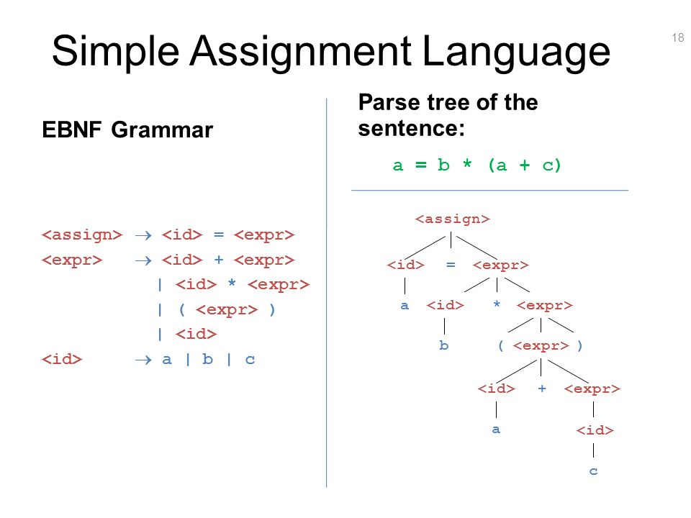

… left as reading exercise

